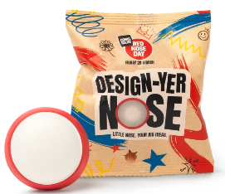
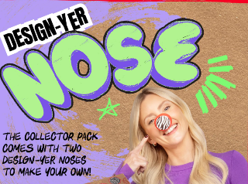
Red Nose Day Competition 2026
This year’s theme: Design-Your Own Nose!

We’re excited to join in the fun by holding our own school competition!
Get creative! Your nose can be silly, sparkly, wacky, or completely out-of-this-world!


Deadline: Please return your designs by Thursday 19th March to Mrs Hulse or a member of the school council.
Let’s see the most imaginative noses you can come up with!
Winners will be announced during Red Nose Day celebrations.
Get designing… and make us laugh! 😄

